SCP-AC Meeting
September 15, 2014: 2:00-3:30 PM

Present: Trina Pundurs (UCB), Xiaoli Li (UCD), Vicki Grahame (UCI), Valerie Bross (UCLA) Sarah Sheets (UCM, chair), Manuel Urrizola (UCR), Elaine McCracken (UCSB), Becky Culbertson (UCSD/SCP), Adolfo Tarango (UCSD/SCP), Beatrice Mallek (UCSF)
Recorder: Valerie Bross
- Announcements:
Sarah Sheets welcomed Manuel Urrizola to SCP-AC as the representative from UC Riverside.

- SCP Update (Adolfo)
Monthly update: See SCP monthly update issues September 12, 2014 for news regarding record distributions for Naxos, Springer, and other packages.

As noted in the monthly update, SCP has finished modifying data in the 001 field with a scp suffix. This change is internal to UCSD; it won’t affect record distribution. But internally, the change is important as it creates a unique OCLC number (distinguished from the OCLC number used for UCSD’s copy of the record). Having a unique OCLC number for SCP records allows SCP and UCSD to use the 001 data as a match-point for overlay of records.

- Vice-Chair nomination (Sarah)
Background: Who should be the Vice-Chair for the coming year, now that Jim Clark (UCR) is no longer available?
Conclusion: Marcia Barrett was nominated as co-chair.

- FAST headings (Adolfo)
Background: At the Operations Committee meeting last May, PCC made a decision that it is acceptable for PCC records to have FAST headings alone (i.e., even if they lack MeSH or LCSH headings). This is also reflected in SCP records for monographs. (Serials are still cataloged one-by-one, so will reflect LCSH.) What is group feeling about records that have only FAST headings for subject access?

Discussion: Irvine discovered this when investigating DDA records that only had FAST. Implications: Cataloging agencies should check to make sure that the catalog tables have been coded to recognize FAST headings are legitimate—otherwise, the system may not allow the records into the catalog. In addition, some care needs to be given in deciding how to index FAST headings. UCI decided to index them in the keyword indexes, not in the subject browse indexes.

Conclusion: Contact Adolfo if you have any comments about these records.

- Review of Collection Manager (Adolfo): See also Appendix 1 for OCLC WorldShare Collection Manager screens.
Background: SCP staff have been investigating the use of the OCLC WorldShare Collection Manager Service for updated SCP records. Using the SCP account. Set up to receive update reports for all records with holdings symbol XXXER.
- Profile: Including conditions: Report changes to: 022, 042, 6X0/6X1 (MeSH & LCSH), 780, 785, 787. Encoding level: report changes to: I or blank. Other changes reported: Publication status changes; re-description to RDA.
- Profile changes: originally, asked for changes to 245 field, but changes too voluminous due to OCLC programmatic changes for RDA (e.g., “et al” to “and others”). Originally asked for broader 6XX reporting, but too many genre heading changes were reported. To eliminate 042 changes next (unnecessary).
- Frequency: Reports daily
- Results: Receiving reports of about 100 records per day; 90-95% are monographs. The serials are being reviewed manually, since there are so few and almost all the changes require manual review such as title changes. Still discussing how to process the monographs.
- Limitations: Since UCSD is also experimenting with Collection Manager and has already associated its OCLC holding symbol, CUS, with its account, SCP can’t filter out the records it modifies from the WorldShare reports. (SCP’s work falls under the CUS holding symbol).
Discussion:
- Accounts: For campuses that have not yet obtained OCLC WCMS accounts and are interested in using OCLC Collection Manager: Fill out a request: http://www.oclc.org/content/forms/worldwide/en/wckb-request.html
After filling out the form, you will receive an email with your credentials & instructions within a week. If you do not hear within a week, contact OCLC support through the form:
http://www.oclc.org/content/forms/worldwide/en/contact-support.html
- Uses: Other campuses that have explored OCLC’s WCMS include: UCI, UCLA, Merced, UCR. UC Irvine experimented with the use of the knowledgebase to set up Standard Collections for Tier 3 titles from four e-book collections. However, ran into limitations: the service sent records for Tier 1 titles mixed in; could not limit to Tier 3 titles. Was a mess.
UCLA set up Query Collections for serial and integrating resource records with CLU holdings.
- Authority control: Question: Will changed records be re-sent through BackStage Library Works to re-do authority work? The only authority work SCP does is at the point of cataloging when we perform NACO and control headings. Once records are distributed, any authority work is the responsibility of the receiving campus. Batch-processed records (most monographs) fall outside this process.
Conclusion:
- Survey: Adolfo will send a short survey to identify possible additional fields to track for change.
- Question: Campuses should consider, in conjunction with this survey, the question: Should WorldShare be supported as an SCP activity?

- Changes to SCP-AC Website (Sarah/Adolfo): See also Appendix II for screen shot
Background: Over the past year, the organizational structure for UC Libraries Advisory Structure has changed significantly (See: http://libraries.universityofcalifornia.edu/groups/files/about/docs/UCLAS_org_chart.pdf ) However, the SCP-AC website has not been updated accordingly. (See http://libraries.universityofcalifornia.edu/scp-ac)
Discussion:
- What is the organizational category of SCP-AC?
SCP-AC is an operational team. However, it does not appear on the list of teams at http://libraries.universityofcalifornia.edu/ot.
- To whom does SCP-AC report?
To SAG3
- Who is the liaison from SAG3?
Still to be determined.
- What are the expectations in terms of annual reports, etc.?
That’s still being worked out.
- Are there any changes needed to the website aside from those related to the new organizational structure?
Conclusion: Sarah Sheets will send questions to the chair of SAG3 to clarify expectations, name of SAG3 liaison to SCP-AC, etc.

Appendix 1. Screen shots of OCLC WorldShare Collection Manager Service (See also topic #5)

Initial Screen:
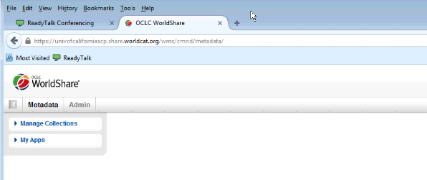

Profile: Option to receive updated records for specified OCLC symbols:
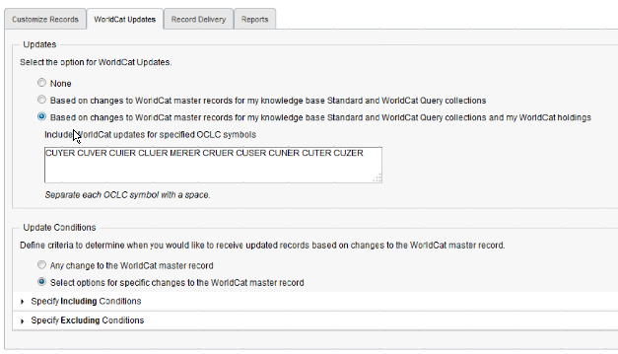

Profile: Including conditions
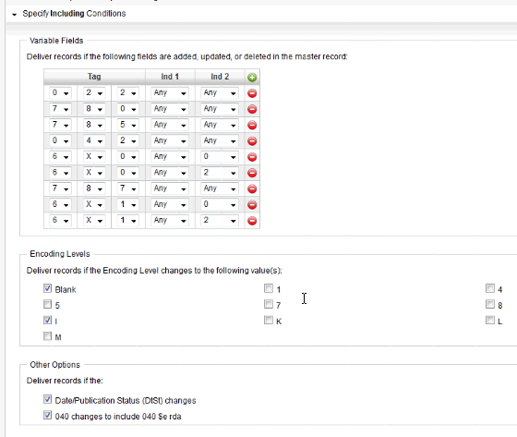

Sample daily report:
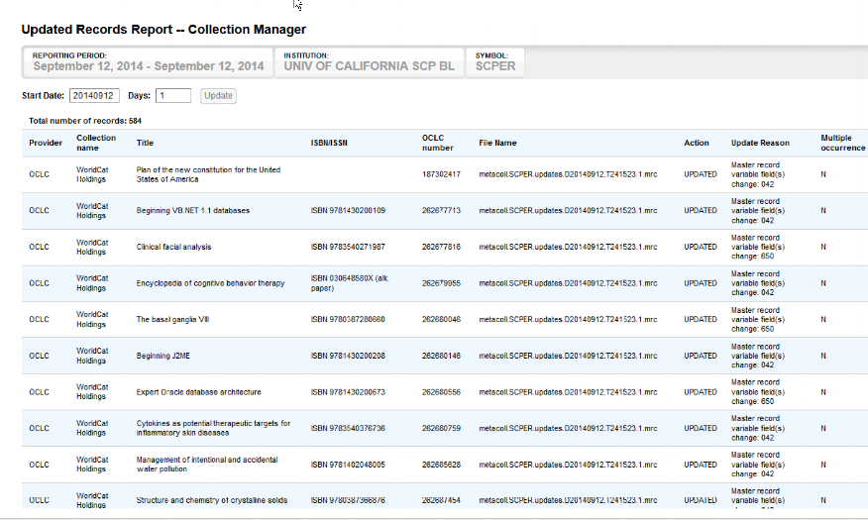
Appendix II. SCP-AC Website

Changes to Website: http://libraries.universityofcalifornia.edu/scp-ac

